STEP 1: Create a Windows VM
In Azure:
- Go to Azure Portal > Virtual Machines > + Create
- Set:
  - Image: Windows Server 2019
  - Size: Standard B2ms (or higher)
  - Username/password: create admin login
- In Networking:
  - Ensure public IP is enabled
  - Add inbound ports: 21, 14147, 50000–51000
- Click Review + Create > Create
- Download RDP file and connect to your VM

STEP 2: Install FileZilla Server
- On the VM, go to:
https://filezilla-project.org/download.php?type=server
- Download and install FileZilla Server
- During setup:
  - Set Admin port: 14147
  - Set Start as service
  - Choose Start interface automatically
- 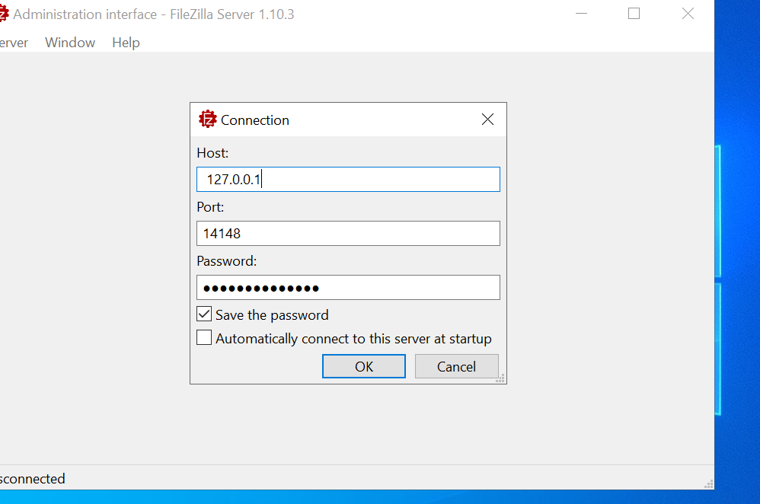

STEP 3: Create Department Folder
Sales folder
Hr folder
Finance folder

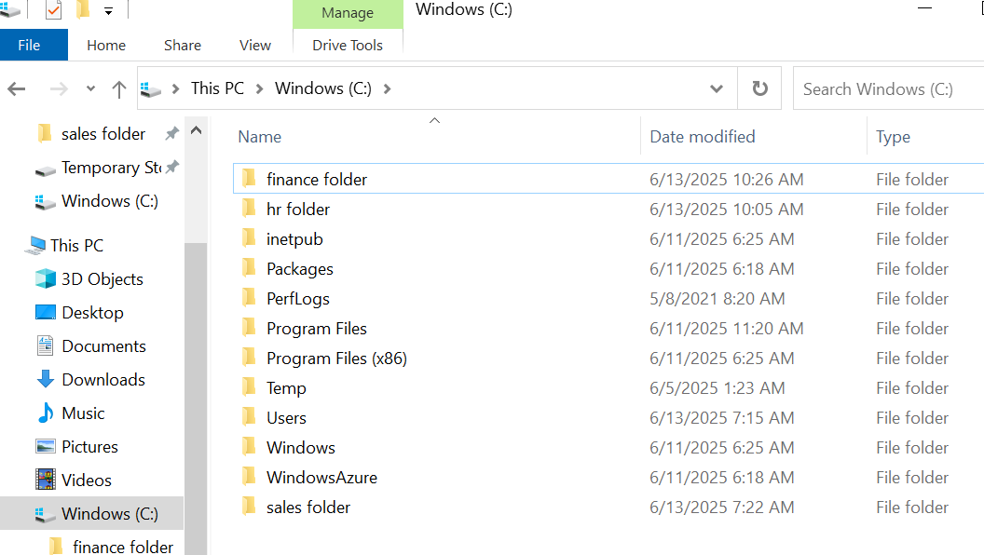

STEP 4: Configure FileZilla Server

. Create Users
Go to Edit > Users:
- Click Add, enter username:
  - salesuser, hruser, financeuser
- Set passwords for each
- Enable the account
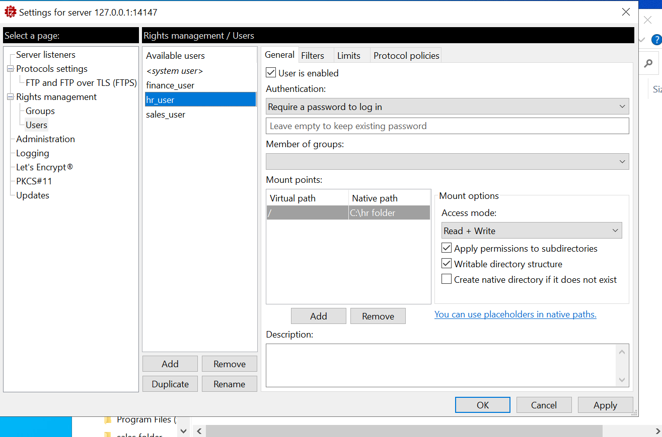

Assign Folders Permissions:
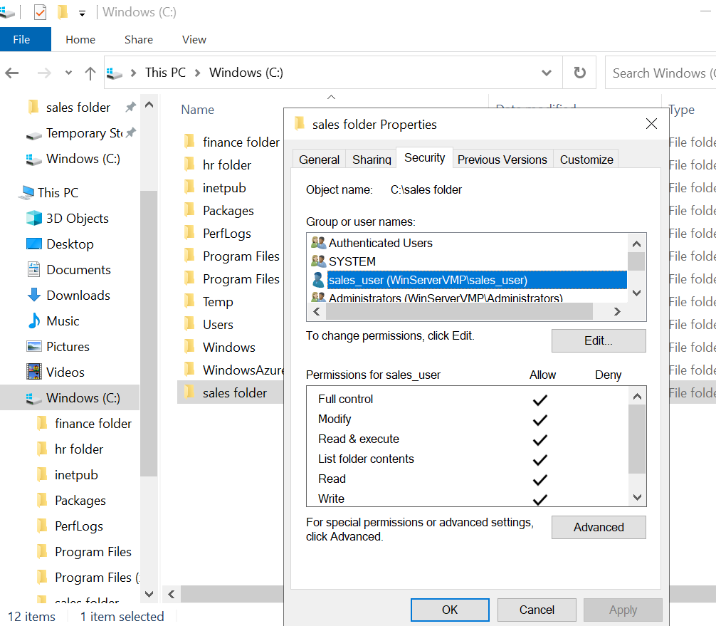

Windows Firewall:
Allow inbound rules for:
- TCP: 21, 14147, 50000–51000

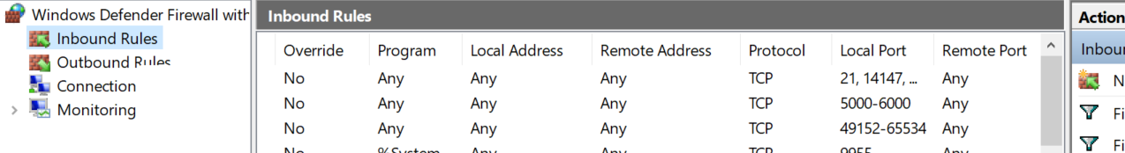

Open Ports in the Windows VM Firewall:

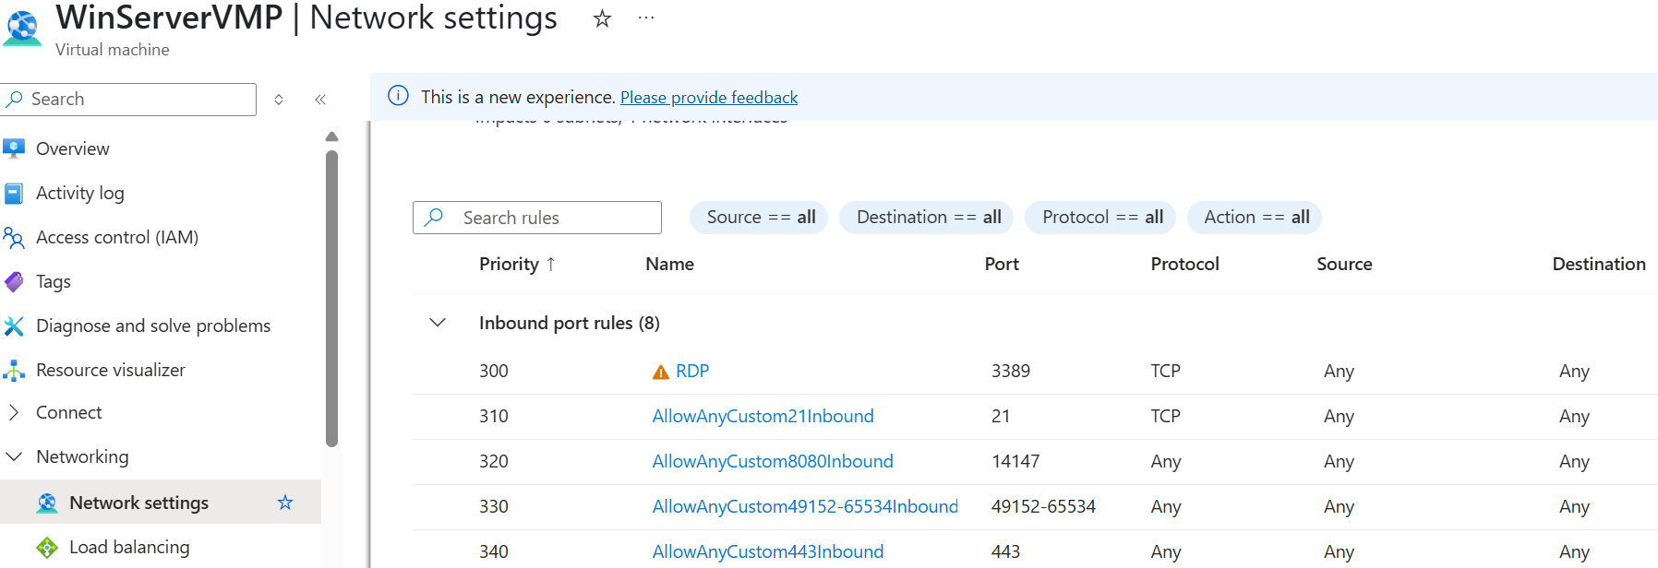

STEP 6: Test FTP Access
Use FileZilla Client or browser:
- Host: Public IP of VM
- Port: 21
- Username: e.g., salesuser
- Password: ********
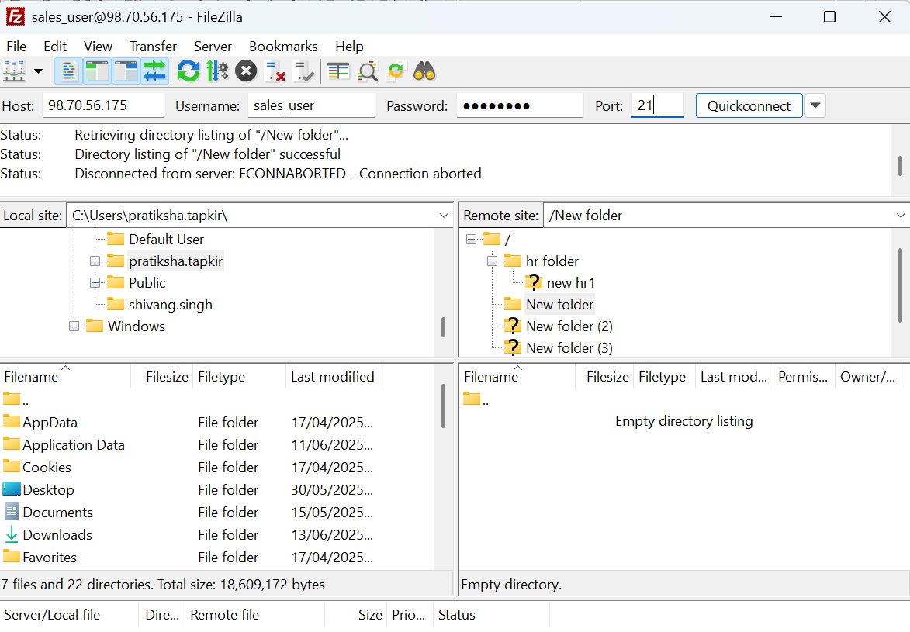

Check that:
- salesuser sees only Sales folder
- hruser sees only HR folder
- financeuser sees only Finance folder

